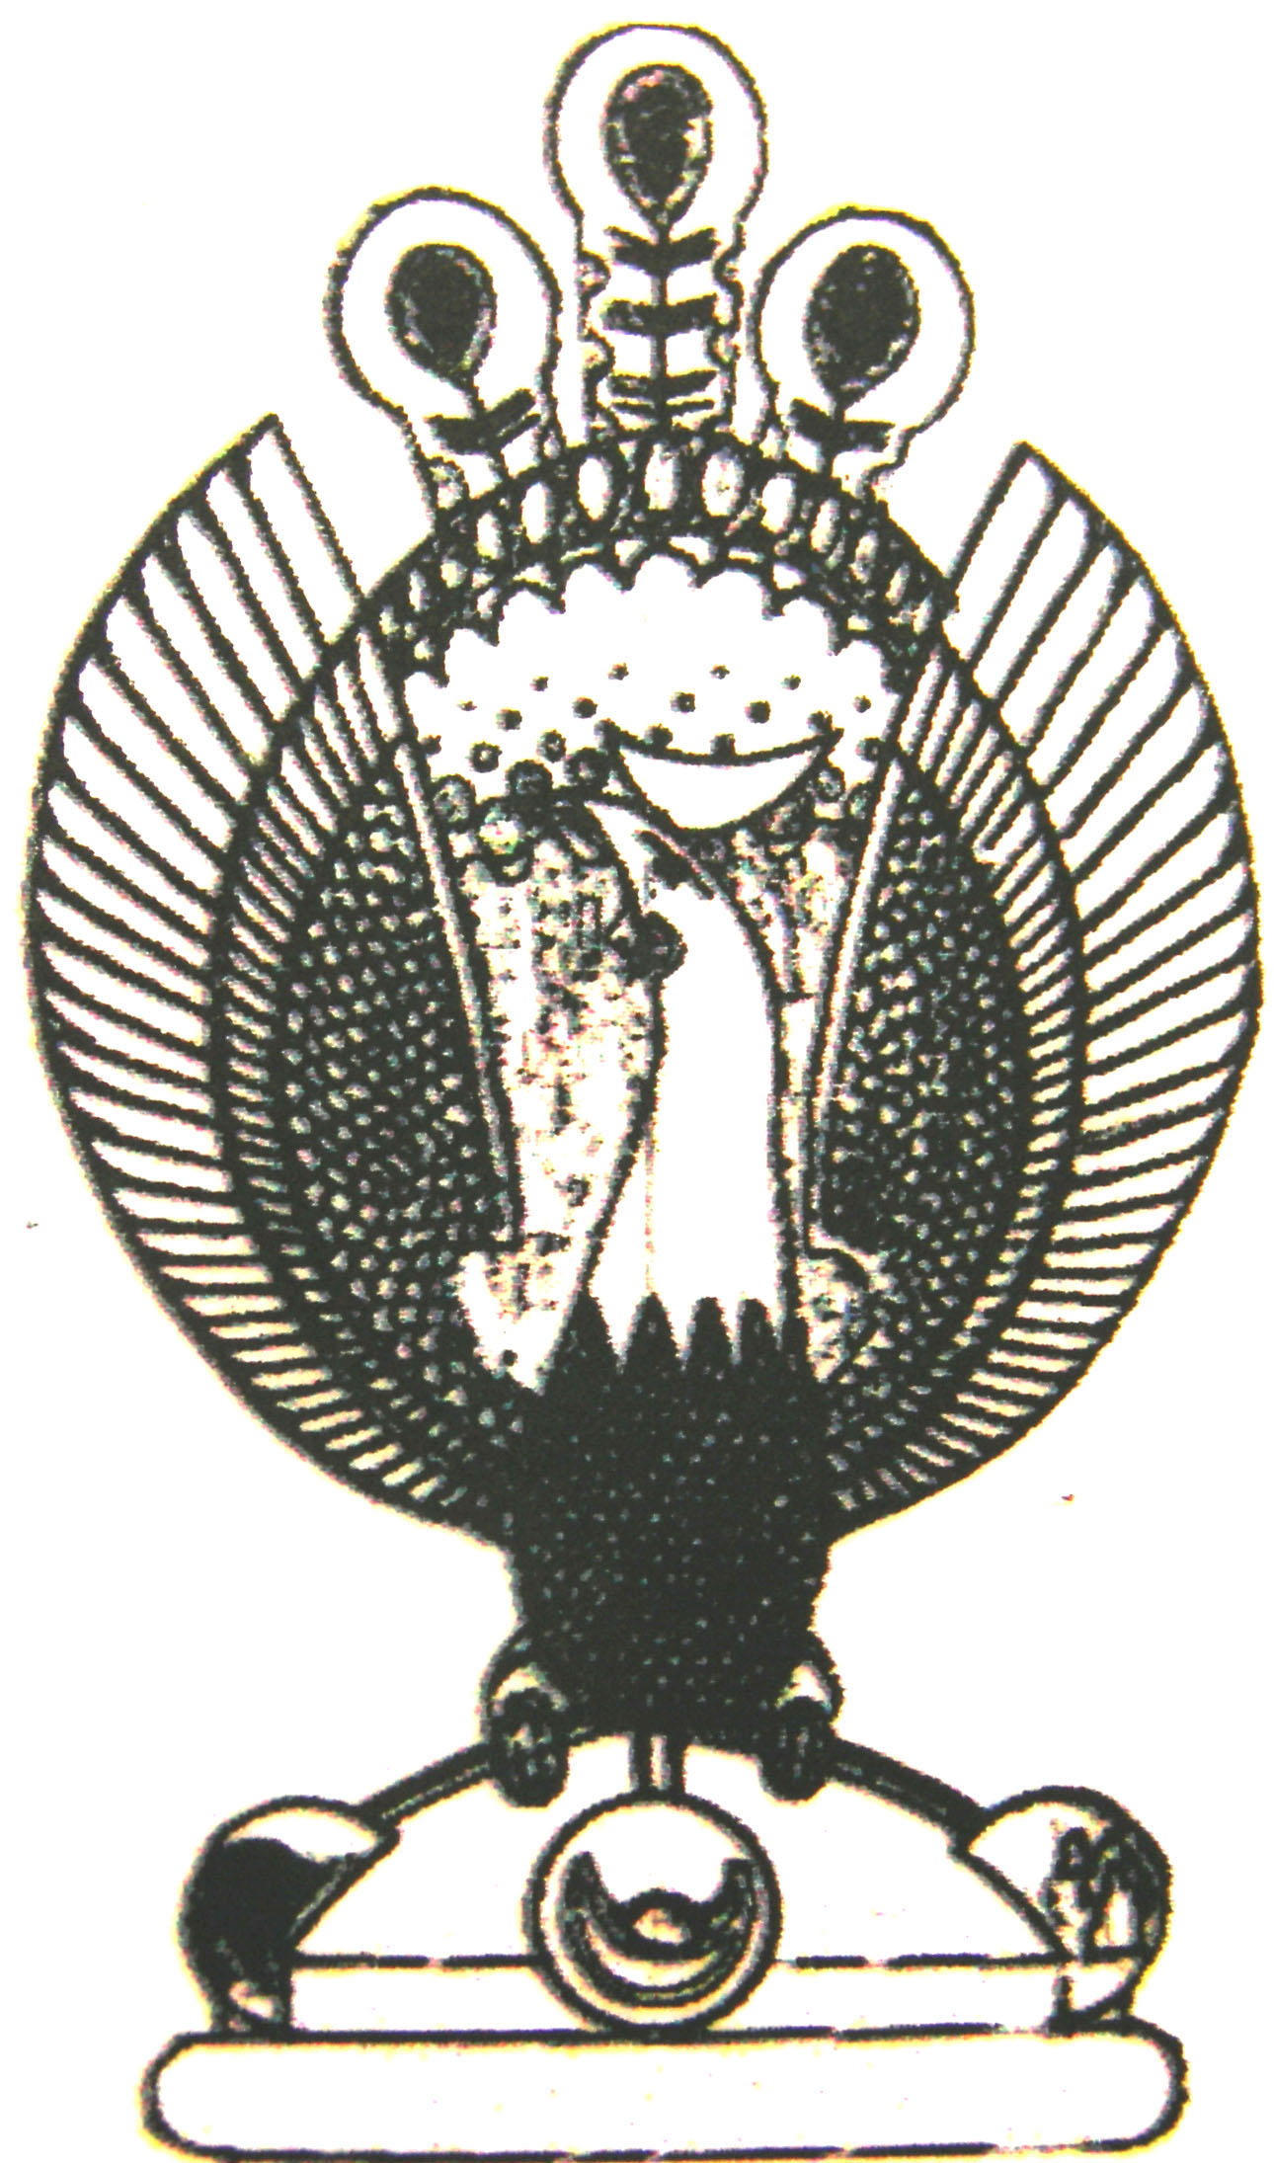

THE HERITAGE

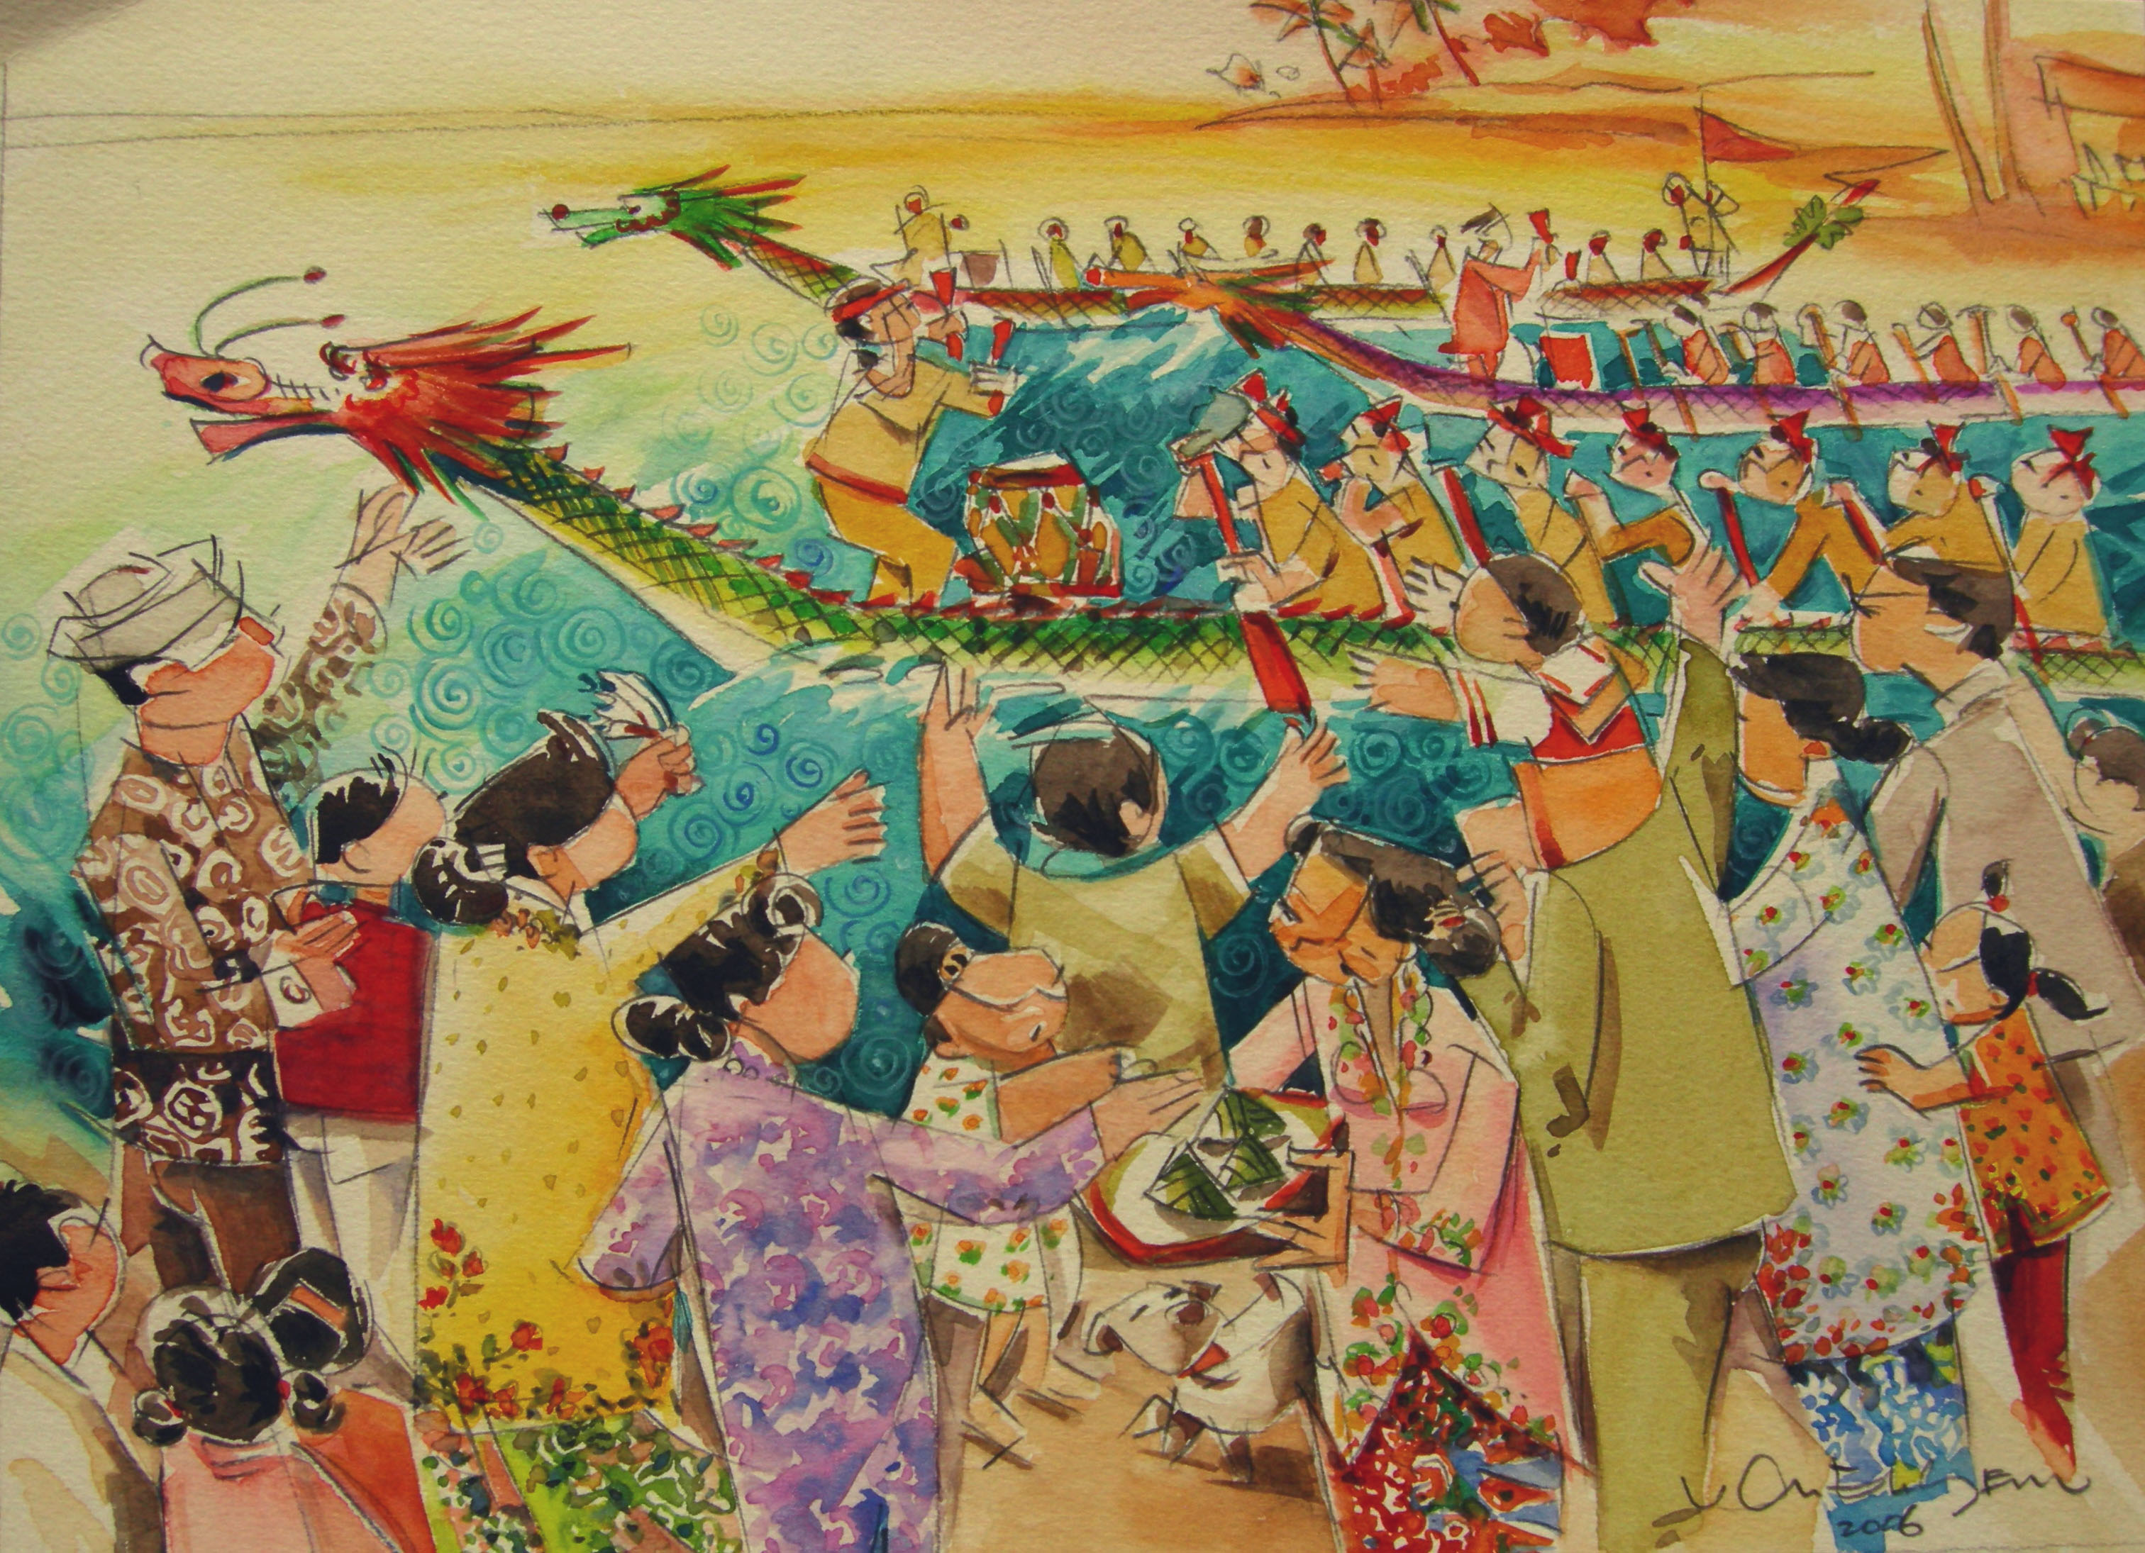
Dragon Boat Festival
Dragon Boat Festival. Peranakans make and eat rice dumplings during this festival.

